**SCREENSHOTS**

**ADAPTIVE EMAIL CLIENT APP**

**SCREENSHOT 1:**

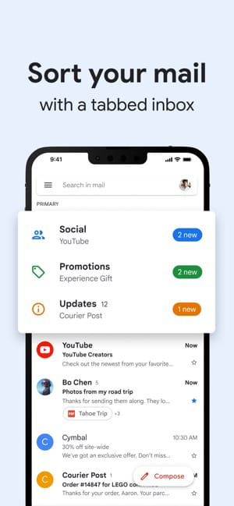

**SCREENSHOT 2:**

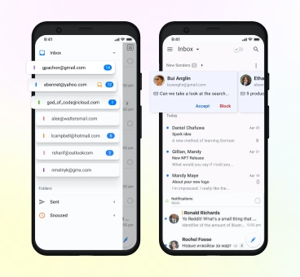

**SCREENSOTS 3:**

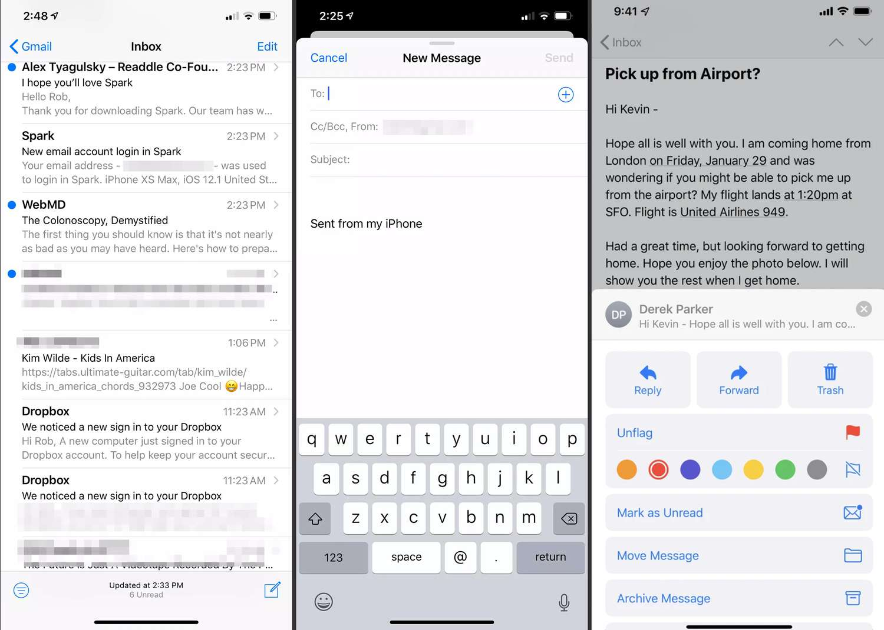

**SCREENSHOT 4:** 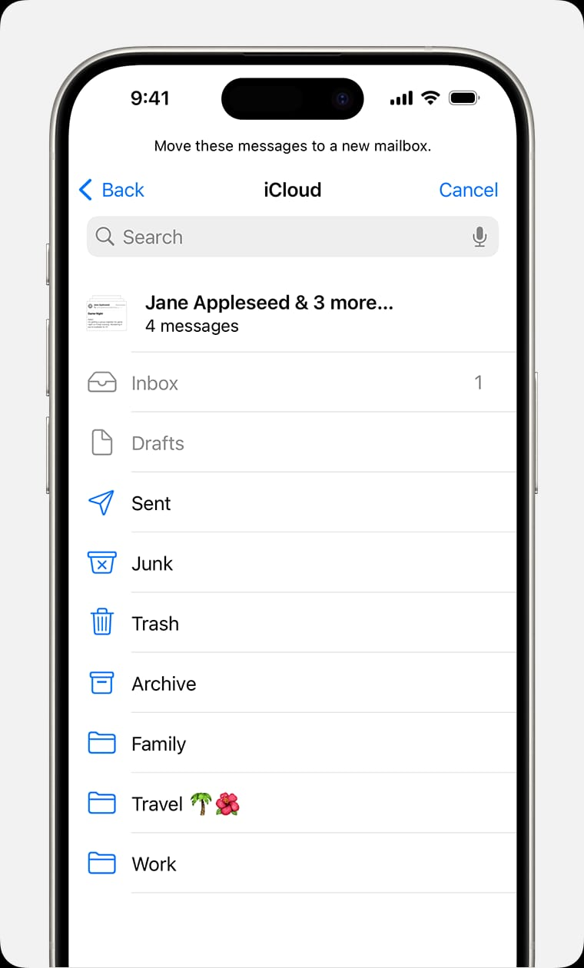

**SCREENSHOT 5:**

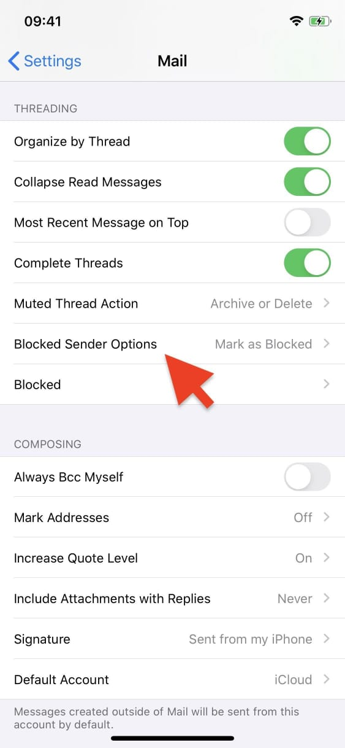

**SCREENSHOT 6:**

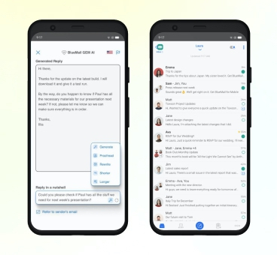

**SCREENSHOT 7:**

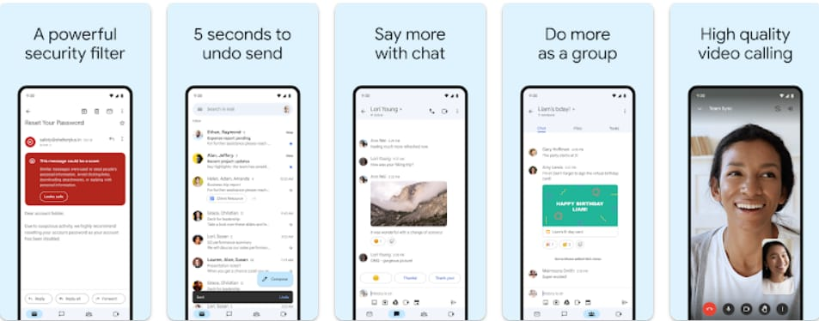

**SCREENSHOT 8:**

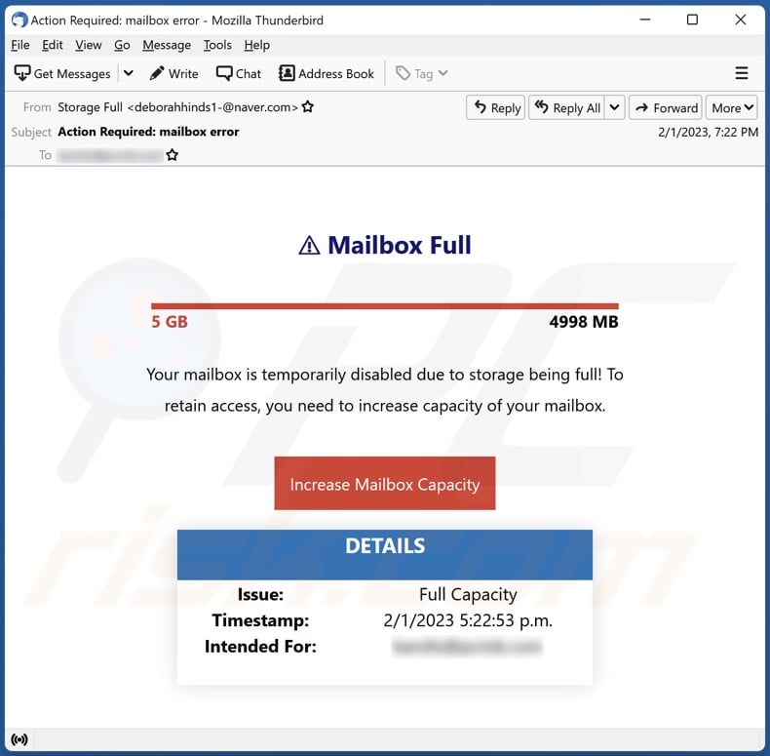

**SCREENSHOT 9:**

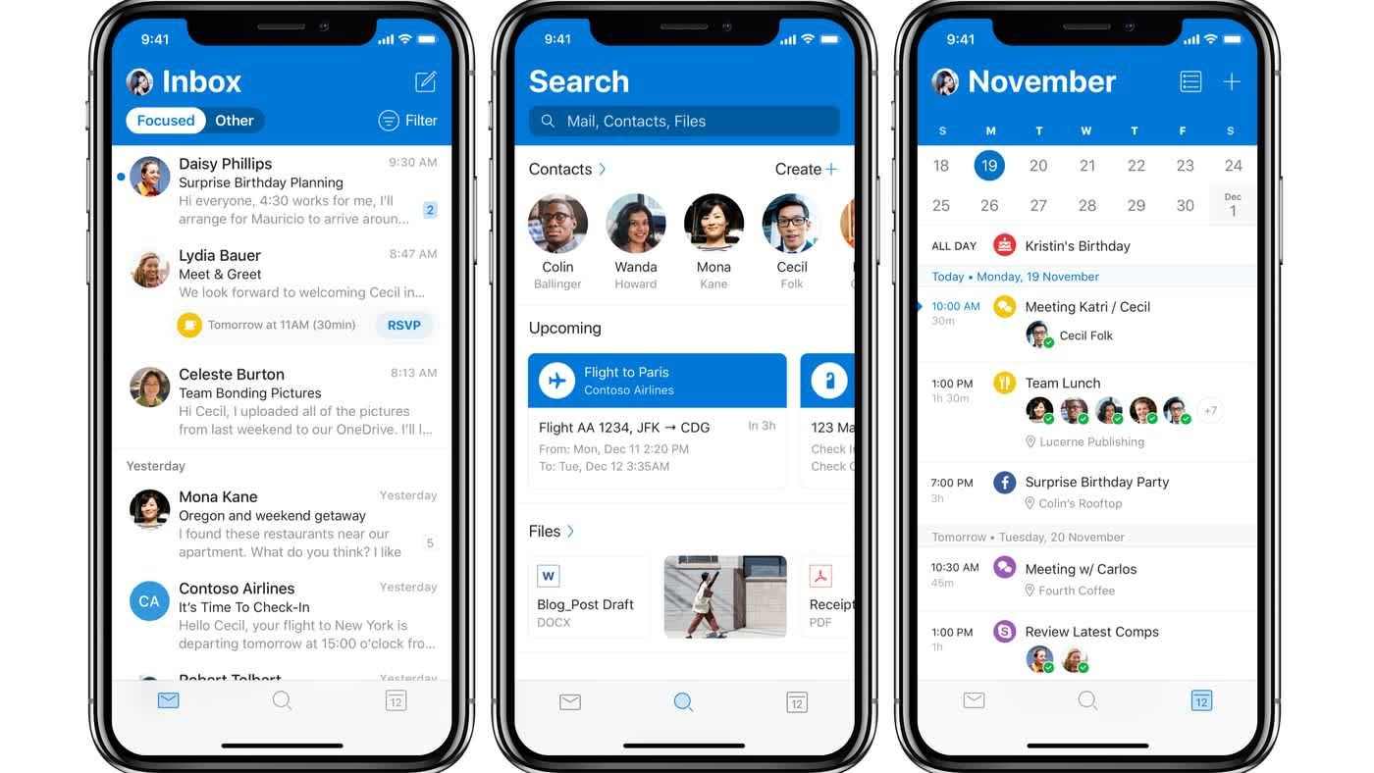

**SCREENSHOT 10:**

